UDP

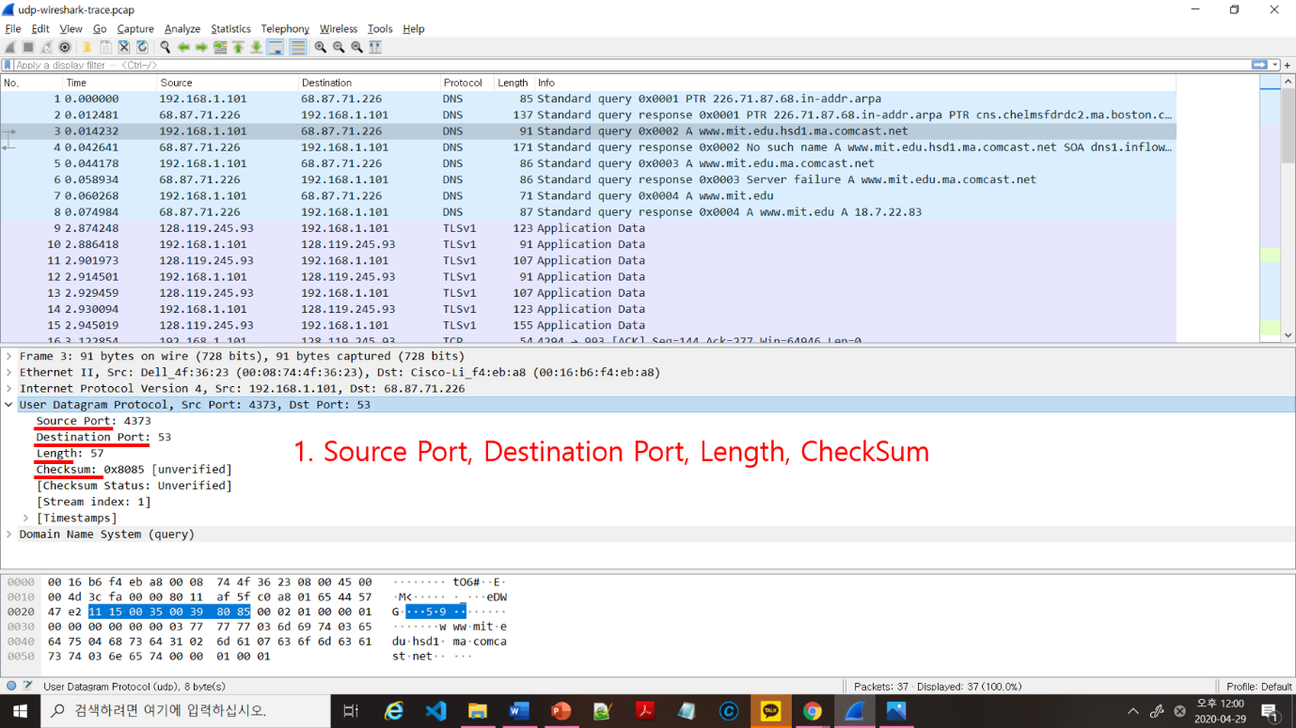

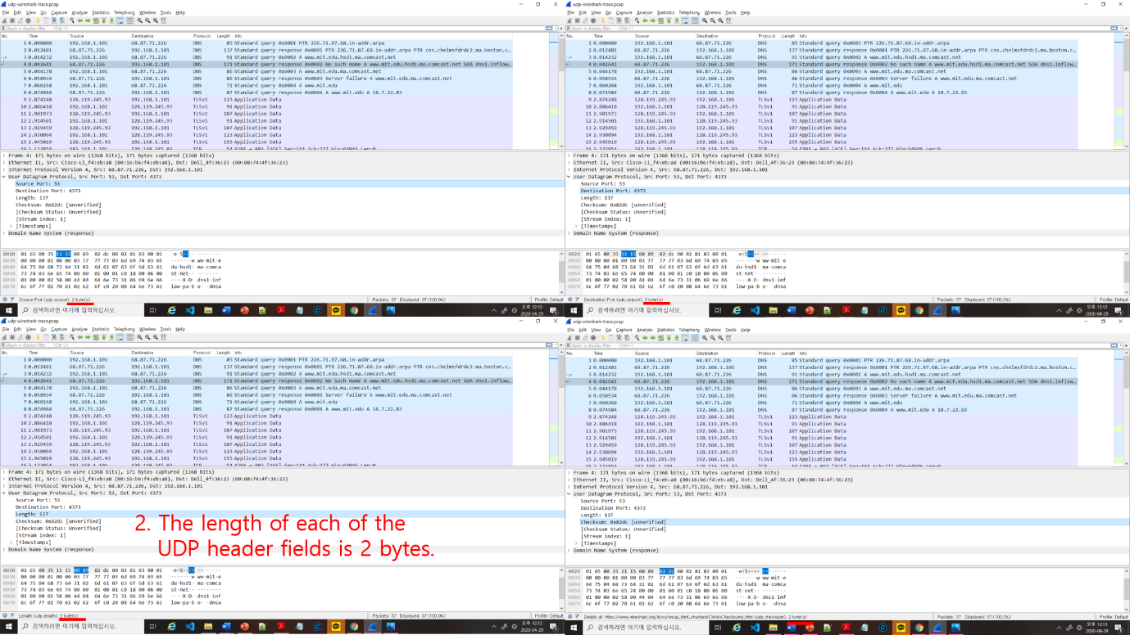

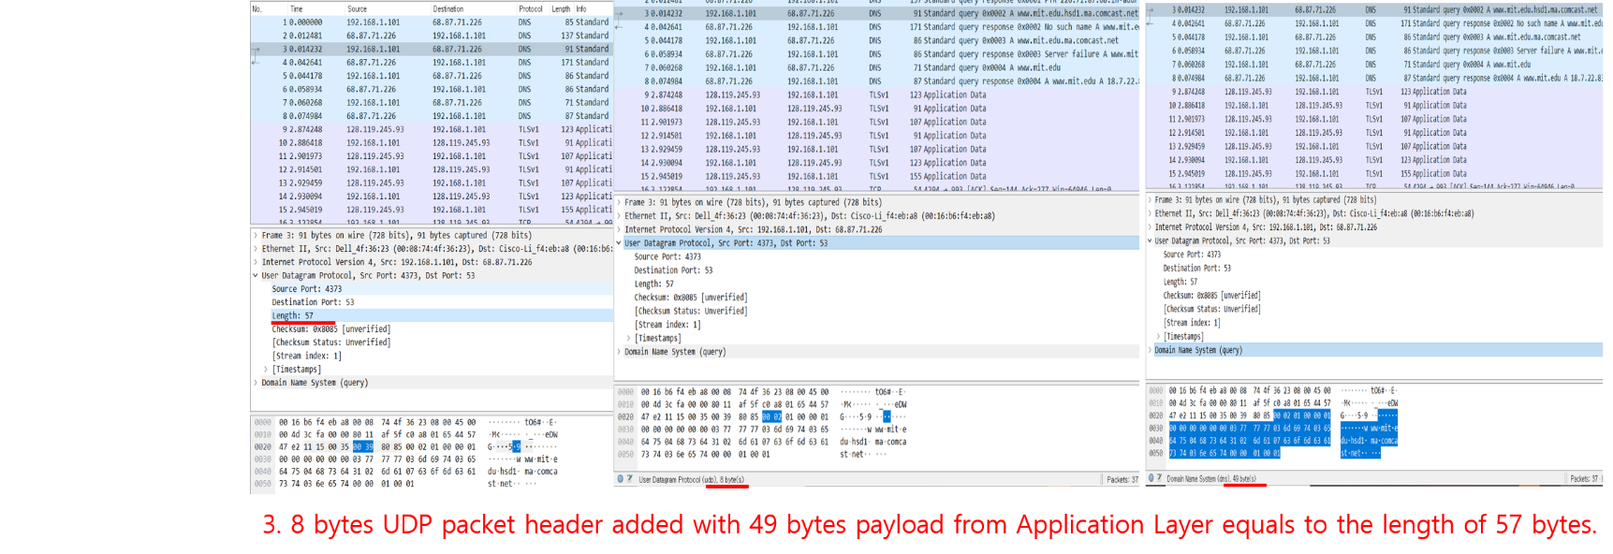

4 . The maximum length with the header included is (65535) bytes. but the actual maximum number of bytes with the header excluded is 65527

5. The largest possible source port number is 65535

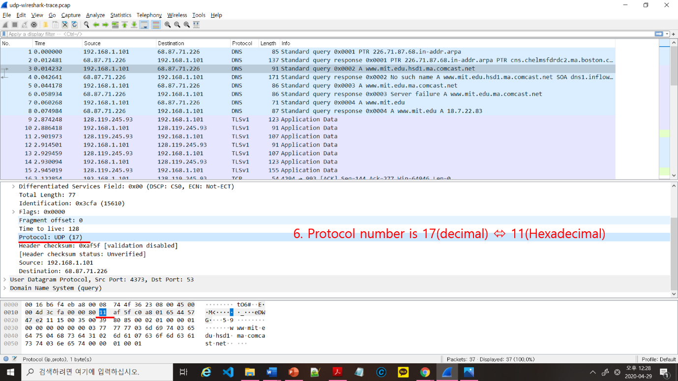

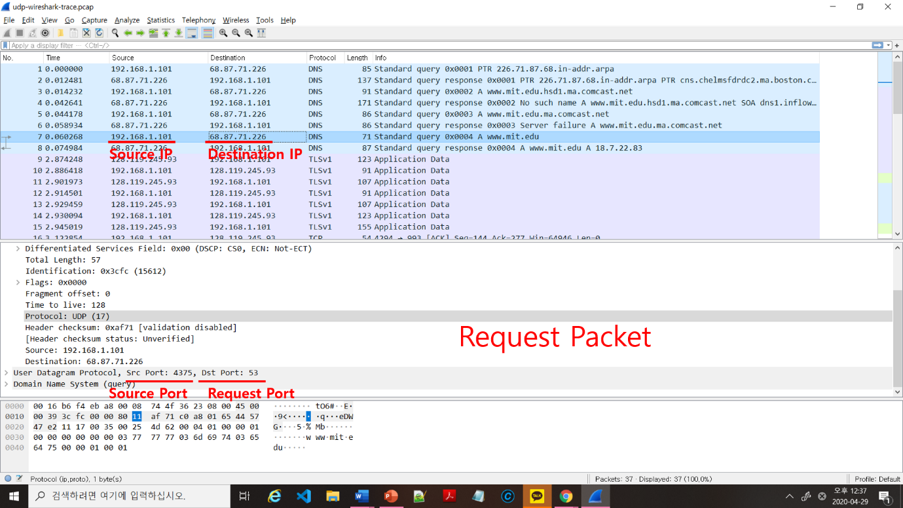

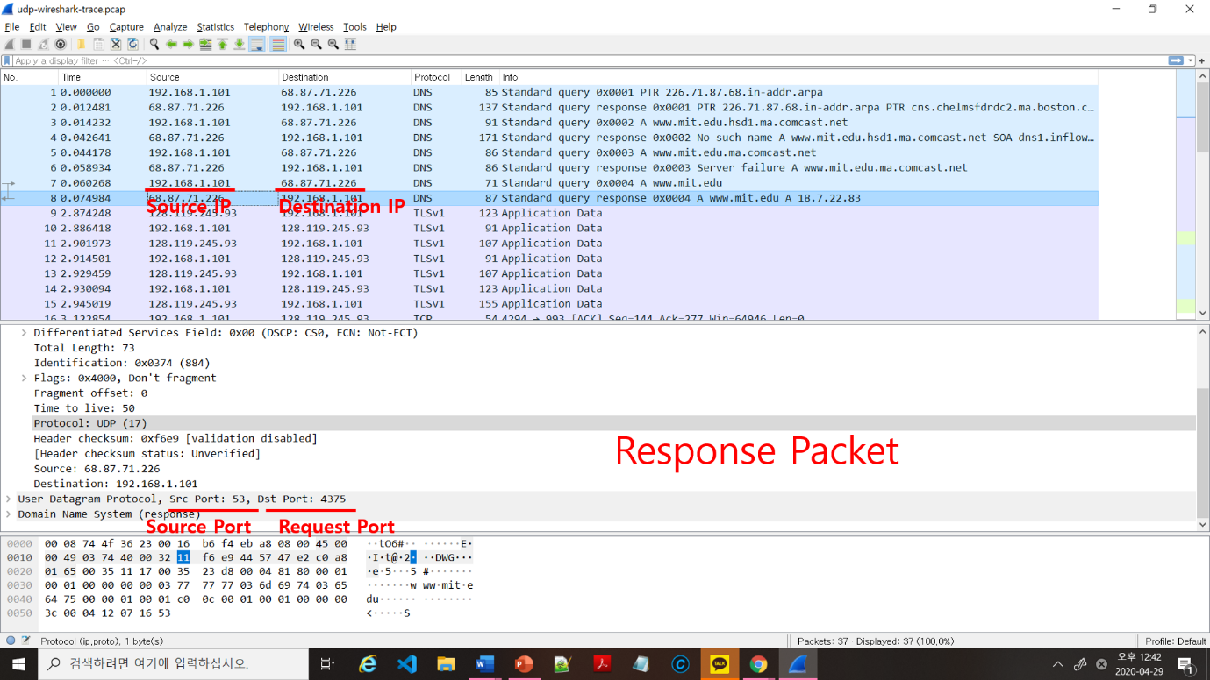

7. The source port number from the source IP sends the request packet to the destination IP’s destination port number. During the sending of a response, the source IP that sent the request packet becomes the destination and it’s source port becomes the destination port. The response sender’s IP and port number turns to the source.